Great—let’s turn that JD into a real system design exercise that actually tests whether you understand:
- Context window optimization
- Memory strategies
- RAG + grounding
- Agentic orchestration
- AI-first delivery

🎯 System Design Problem (Interview-Level)

🏦 Build: Enterprise AI Copilot for a Bank

Objective
Design an AI system that:
- Answers employee queries (policies, customer data, workflows)
- Automates tasks (loan processing, compliance checks)
- Provides decision support (risk, fraud, ops)

🧱 1. High-Level Architecture
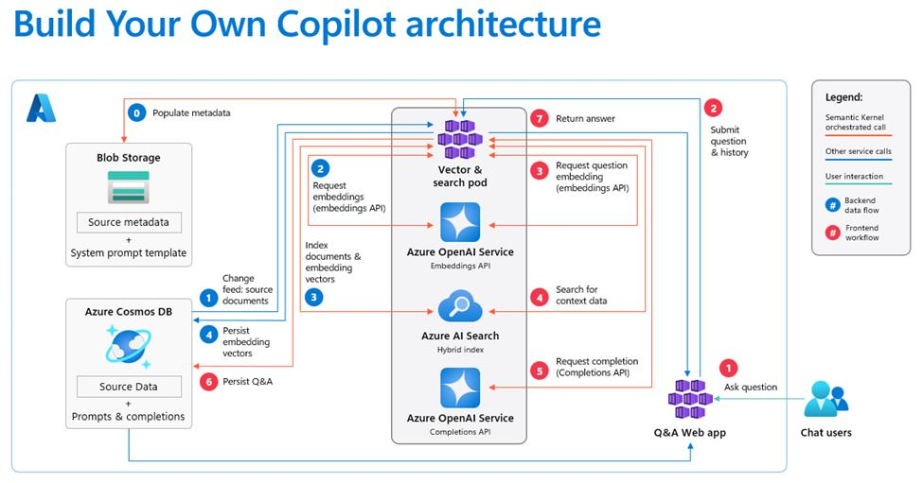
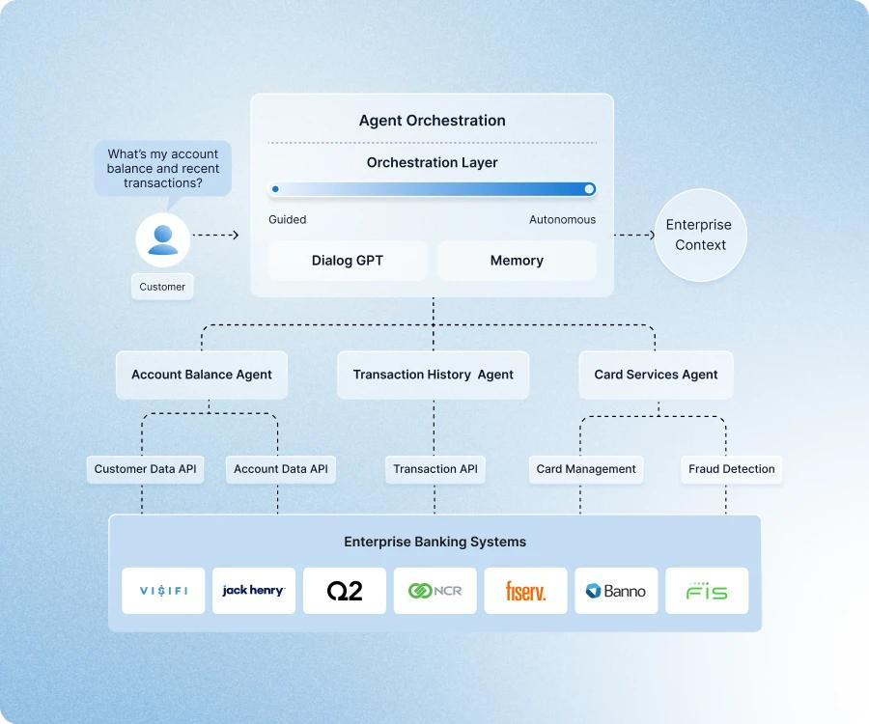
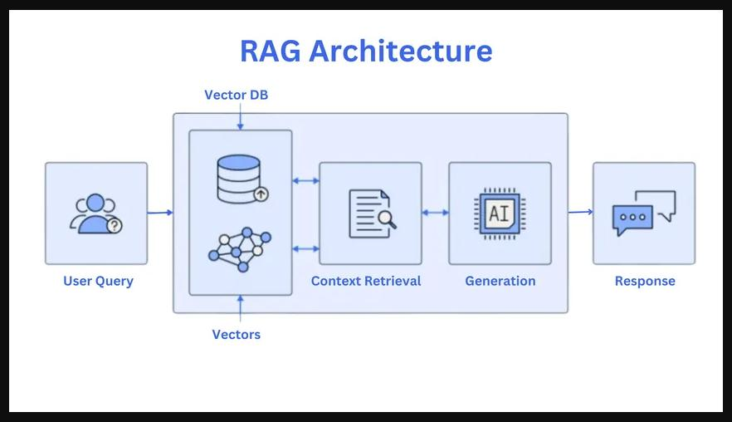
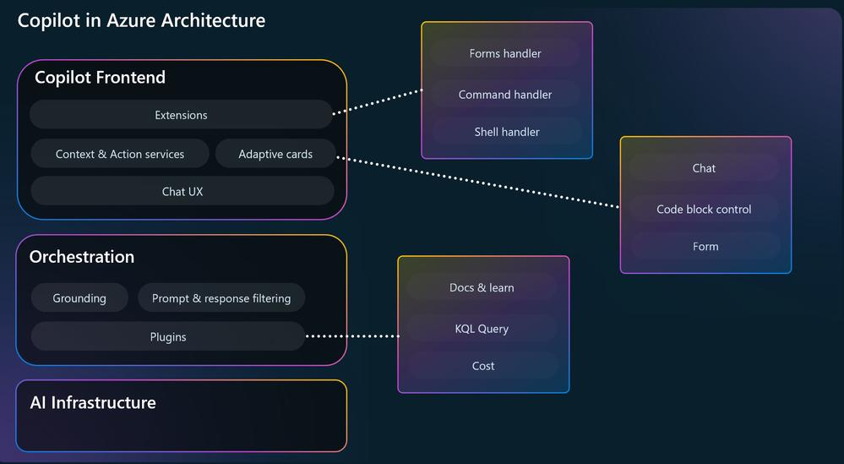
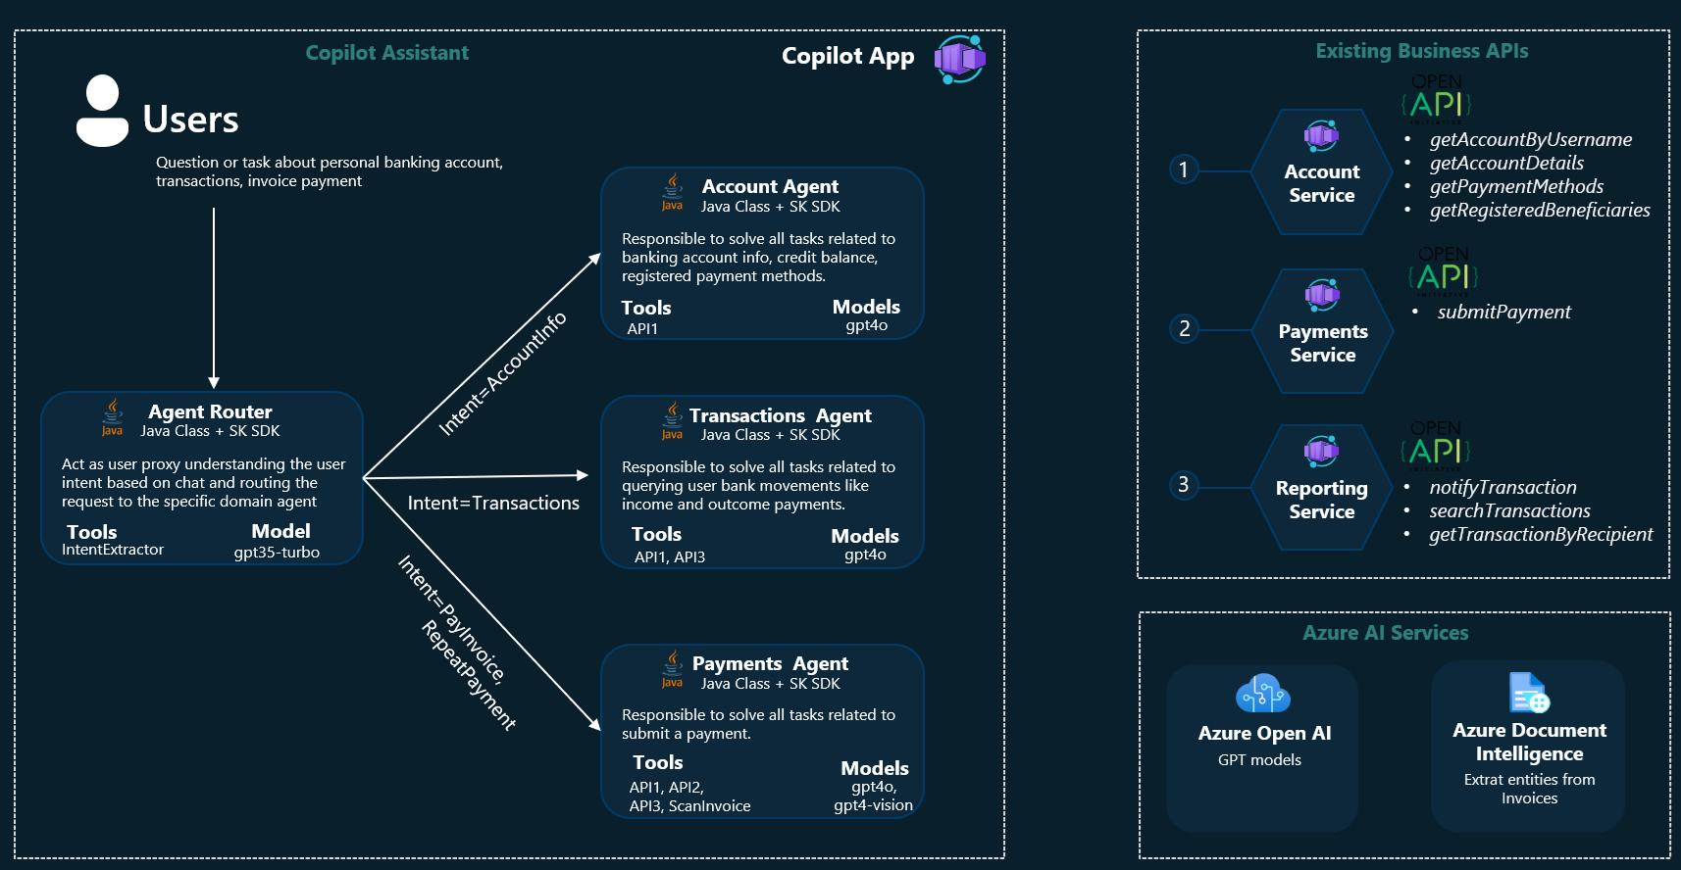
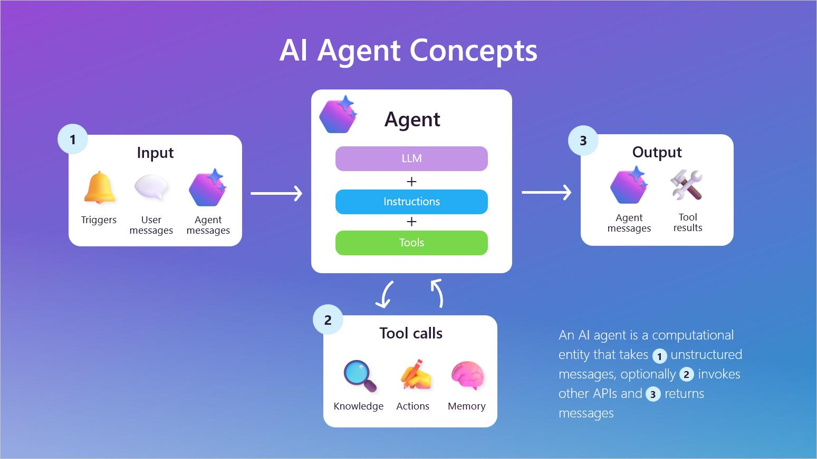
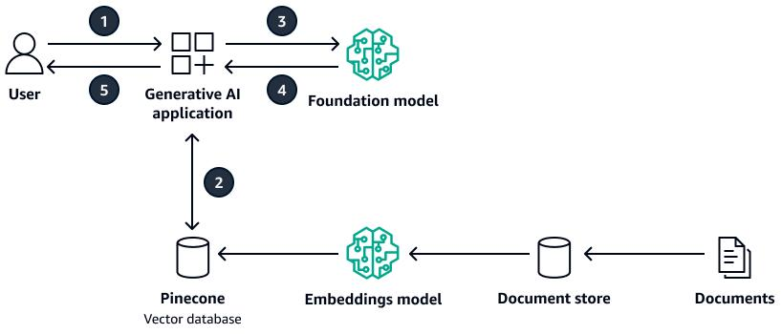

Core Components
Layer | Tech
UI | Web / Teams bot
API Layer | .NET Core APIs
Orchestration | Agent layer
AI Models | Azure OpenAI Service
Retrieval | Azure AI Search
Storage | Blob + DB + Vector index

🧠 2. Request Flow (End-to-End)

Example Query:
“Why was this loan rejected?”

Step-by-step:
1. User query received
2. Intent classification (info / action / decision)
3. Memory retrieval (user + history)
4. RAG retrieval (relevant documents)
5. Context optimization (filter + compress)
6. LLM reasoning
7. Tool/agent execution (if needed)
8. Response generation
9. Memory update

⚙️ 3. Context Window Optimization (Applied Design)

🔹 Pipeline
User Query
↓
Retriever (Top-K documents)
↓
Re-ranker
↓
Context Builder
↓
Token Budget Enforcer
↓
LLM

🔹 Key Design Decisions

1. Chunking Strategy
- 300 tokens per chunk
- 15% overlap
- Metadata: source, timestamp, department

2. Retrieval Strategy
- Top-K = 5
- Hybrid search:
  - keyword + vector

3. Context Builder
[System Instructions]
[User Query]
[Top 3 Ranked Chunks]
[Optional Memory Summary]
👉 NOT dumping all retrieved data

4. Token Budget Enforcement
Example:
Component | Tokens
Instructions | 300
Query | 200
Context | 2,500
Memory | 500
👉 Hard limits enforced in code

🧠 4. Memory Strategy (Applied)

🔹 Memory Layers
Type | Storage | Use
Short-term | Redis / cache | recent chat
Long-term | Vector DB | past interactions
Semantic | Search index | enterprise docs
Episodic | DB logs | audit trail

🔹 Memory Flow
User Query
↓
Retrieve:
- Recent session memory
- Relevant past interactions
↓
Merge with RAG context
↓
Send to LLM
↓
Store:
- Important facts
- Decisions
- Summaries

🔹 Smart Memory Rules

Store only:
- user preferences
- important decisions
- repeated patterns

Do NOT store:
- raw chat logs (summarize instead)

🤖 5. Agentic AI Layer (JD Critical)

🔹 Multi-Agent Setup
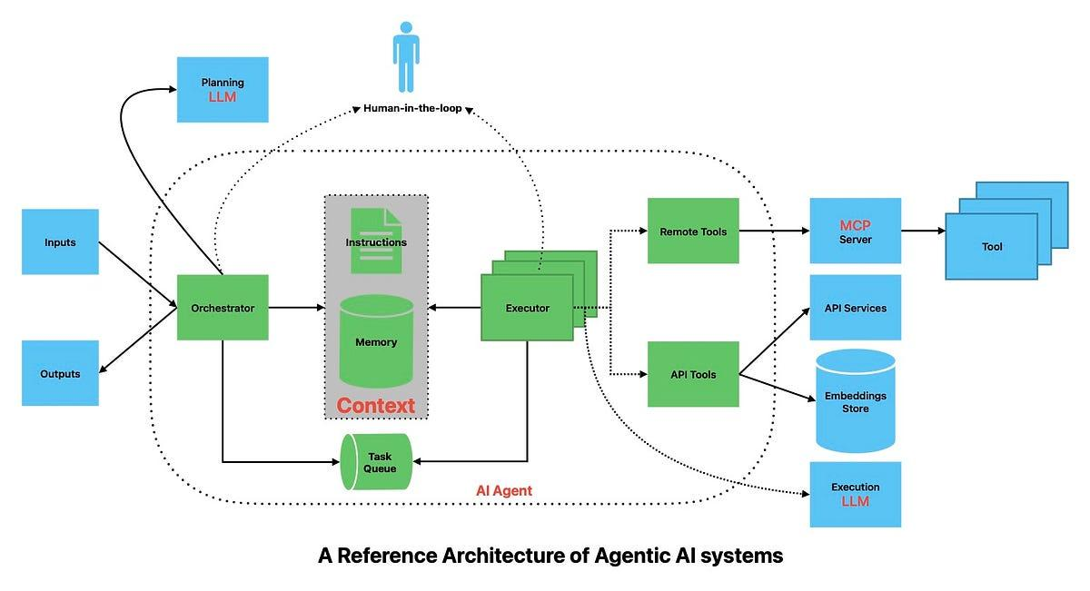
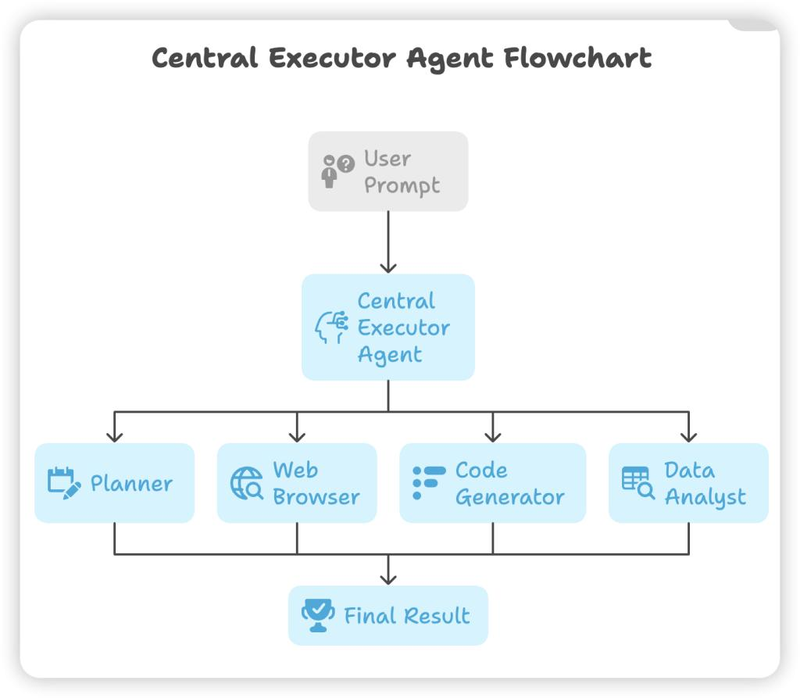
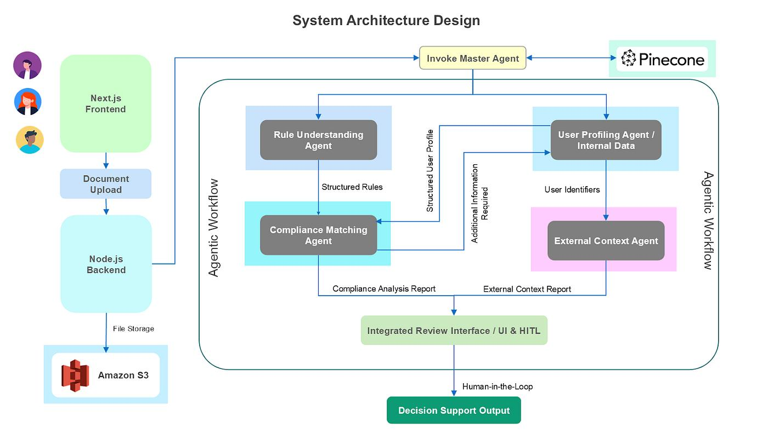
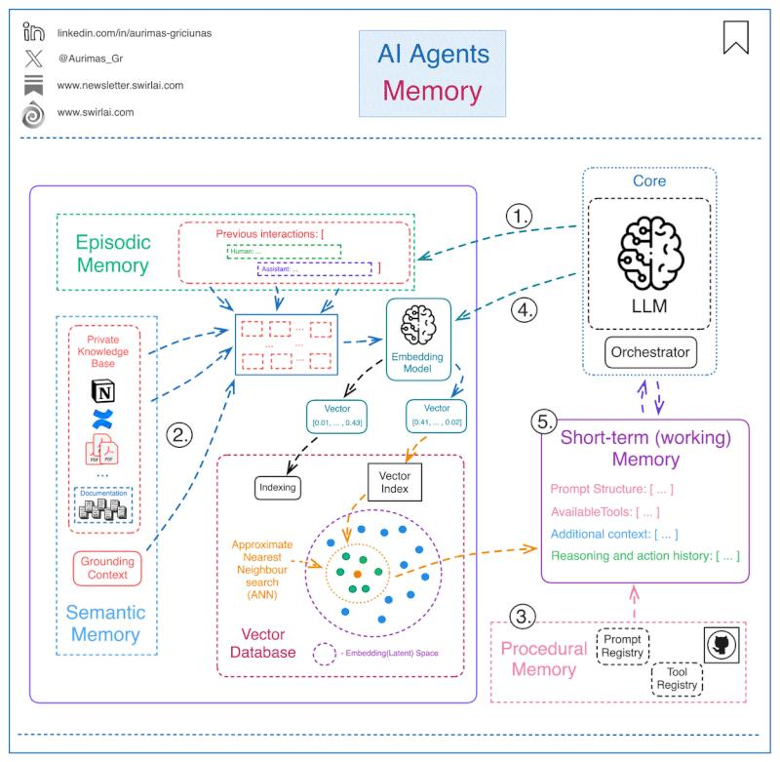
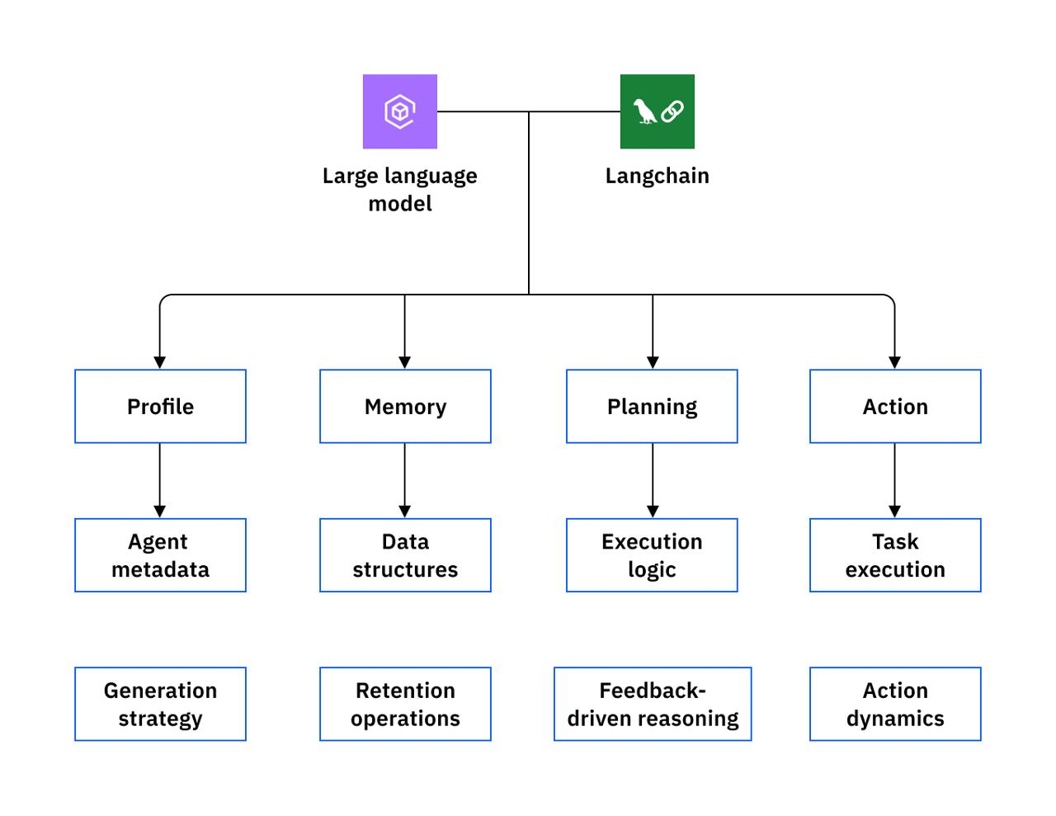
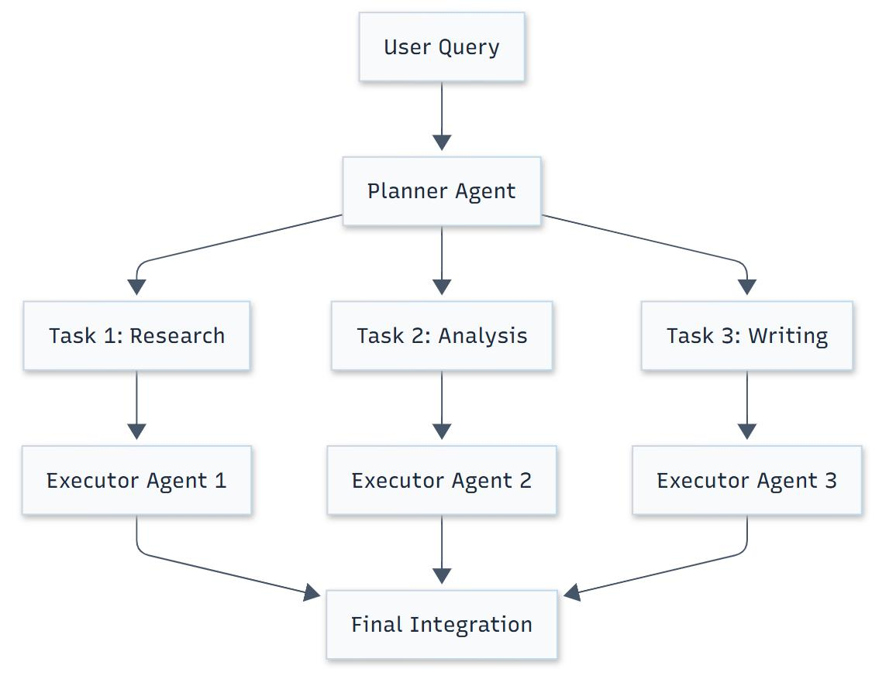
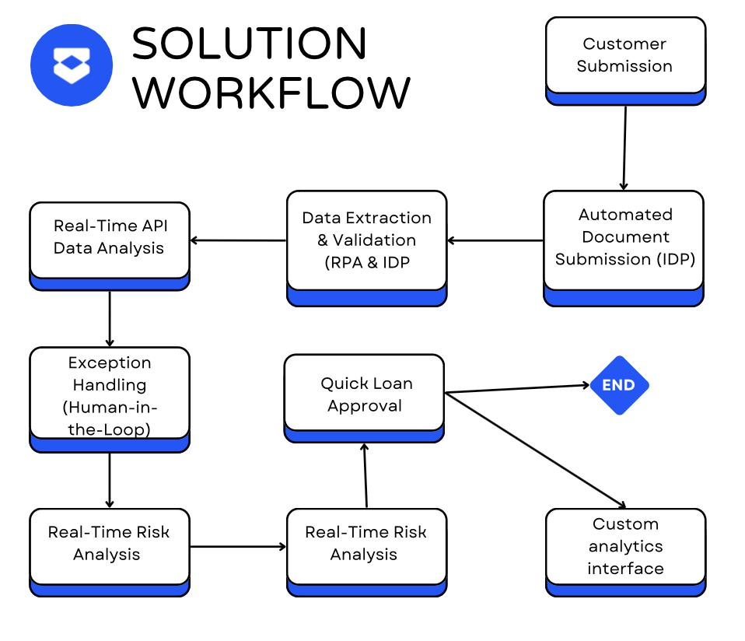

Agents:
Agent | Role
Planner | Understand query
Retriever | Fetch data
Executor | Call APIs (loan system)
Validator | Check compliance
Responder | Generate final answer

🔹 Example Flow
Loan query:
- Planner → identifies “loan rejection analysis”
- Retriever → fetches:
  - policy docs
  - customer data
- Executor → calls loan system API
- Validator → checks compliance rules
- LLM → generates explanation

🔐 6. Responsible AI (Must-have)

Enforced at multiple layers:
- PII masking
- Role-based access
- Audit logging
- Prompt filtering
👉 Especially critical in banking

🚀 7. AI-First Delivery (How YOU Lead This)

What you do as Principal Consultant:

🔹 Delivery
- Define:
  - architecture blueprint
  - reusable accelerators

🔹 Engineering Excellence
- Create:
  - RAG framework template
  - agent orchestration SDK

🔹 Copilot Adoption
Using GitHub Copilot:
- enforce AI-assisted coding
- build prompt libraries
- accelerate dev cycles

🔹 Crisis Handling
If system fails:
- debug:
  - retrieval quality
  - context overload
  - memory noise

📊 8. Trade-offs You MUST Explain (Interview Gold)
Problem | Trade-off
Accuracy vs cost | More context = higher cost
Latency vs reasoning | agents slow but smarter
Memory size vs noise | more memory = more confusion
RAG vs fine-tuning | flexibility vs performance

🧪 9. How Interviewer Evaluates You
They check if you can:
✅ Avoid “dump everything into prompt”
✅ Design memory layers clearly
✅ Explain RAG pipeline deeply
✅ Handle enterprise constraints
✅ Think in trade-offs

💡 Final Insight
If you can confidently explain:
- “What goes into context vs memory”
- “How to reduce tokens but improve accuracy”
- “How agents orchestrate workflows”
👉 You are already operating at Principal Consultant level

If you want, next I can:
- Turn this into a mock interview (they grill you deeply)
- Or give a real .NET + Azure implementation blueprint
- Or design a multi-industry version (retail / IoT / manufacturing)

